Ideas and Notes
- 01/05/2026 7:30 am: On first numeric question, bot failed due to not incrementing by large enough number. Implemented change in claude code. See jupyter notebook C:\Users\Donni\projects\metac_bot_Spring_2026\jupyter\0001_GPR_Low_Variance_Fix_Demo_cc_05-01-2026.ipynb
- 01/05/2026 9:45 am: Observation: very blocky fall off at edge of numeric distribution https://www.metaculus.com/questions/41385/
  - Idea: Fit two left half and right half of distribution with half normal distributions as fits to values. Would replace Gaussian Process Regression, but forced to include values to low percentiles and high percentiles.
- Idea: make and maintain in tournament mindmap
- Use Claude Search. From Emdash analysis, Claude search looks ok. https://predictably.substack.com/p/better-ai-fact-finding-through-model
  - 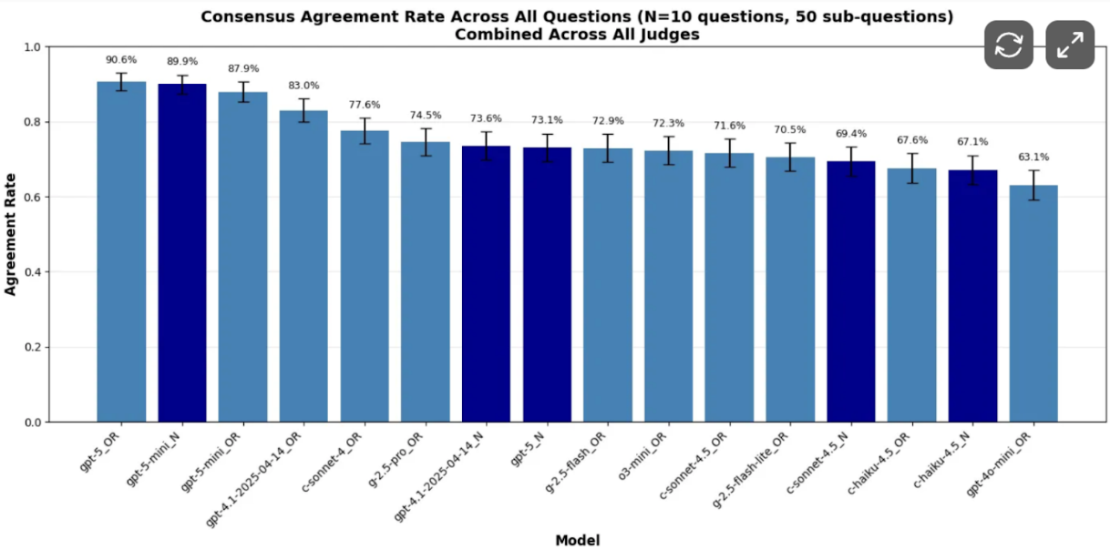
- Observations 1/7/2026
  - Binary Forecasts are all very near 50%
  - There are only 3 saves to the forecast summaries zip
  - Note Spring tournament questions have not restarted. Nothing on Discord
- Forecast save behavior
  - Github forecast-summaries() zip never contains more than summaries for 3 questions
  - First 3 zips had only one question, 4th had 2, 5th had 3. In zip files (5) to (11), the summaries always contained the same first two questions, and the last one often changed
    - My guess is the last active question is saved, replacing the previous last one, but that I was checking before a new question was forecast.
    - Also possibly just saving the most recent forecast, while retaining the two recent ones
- Ideas
  - PC script that downloads forecast summary zip every 20 minutes, extracts any new files
  - Edit condensed summary to capture the full set of summary values submitted to aggregation.
- Forecast save problem in GitHub 01/07/2026
  - Claude code - still not saving artifacts correctly - Mostly fixed by saving each question as a new artifact with another name
    - See doc outlining behavior vs. desired behavior: GitHub Actions Desired vs Actual Behavior for Saving Forecast Summaries 01-07-2026.txt
    - Also have a script that downloads summaries to PC (not tested) need to test
    - Remaining small issue: the zip file with saves has two old question summaries (always the same two)... need to update
  - Verify bias to 50% on binary questions (only on minibench? Or both mini-bench
- Actions
  - Analyze numeric results in jupyter
    - Extract fall numeric forecast examples
    - Does bi-normal capture distribution better than straight GSR?
    - Should median be intersection of low and high regressions of bi-normal
      - I.e. test alternate aggregation methods.
- Ideas
  - Automate Peer Scoring
    - Use API and or web page for question information (get Claude to scrape??)
  - Understand Metaculus CDF code using Claude Code… I may be missing some basics. (for instance, is it cumulative or histogram)
- Linearization with probit 01/10/2026 002g Natural and Probit - Extract binary forecasts, test probit-probit & natural scale, 01-10-2026.ipynb
  - Probit-Probit linearizes the 72 binary forecast scenarios about 90% of the time
  - For binary forecast, average of p40 to p60 values looks like the best single estimate than median or GSR… maybe p (note we only care about the best central value for probit)
  - 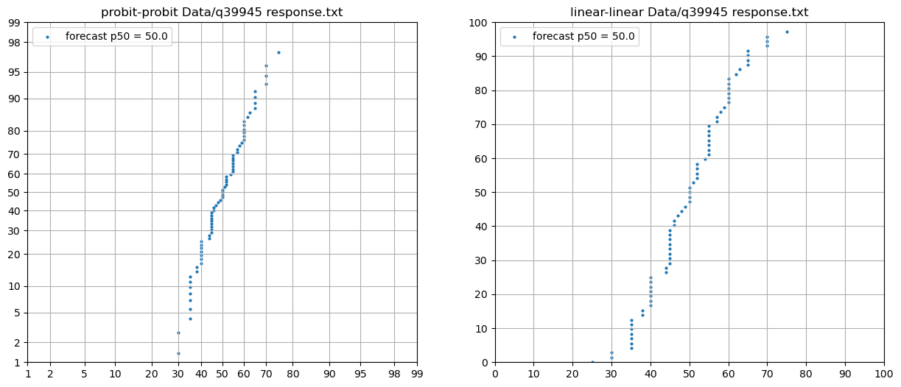
- Best NUMERIC forecast distribution, TENTATIVE
  - Simple probit-probit fit about 80% of the time
  - Segmented linear-probit (3 or 4 segments?) the remainder
  - Implement based on Rsquared thresholds (measure some examples, refine)
  - Definitely need the probit-probit to extend forecasts to p1 and p99
  - There are available algorithms for segmenting the curves (google Python Code for linear segmentation of a curve)
    - Pwlf library for fitting specified number of segments
    - scipy.optimize.curve_fit
  - 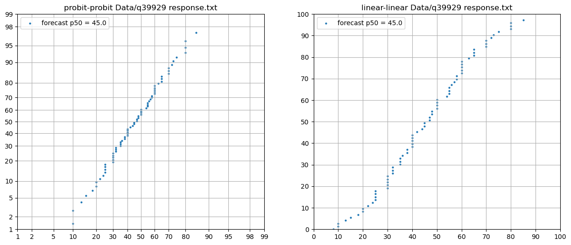
  - 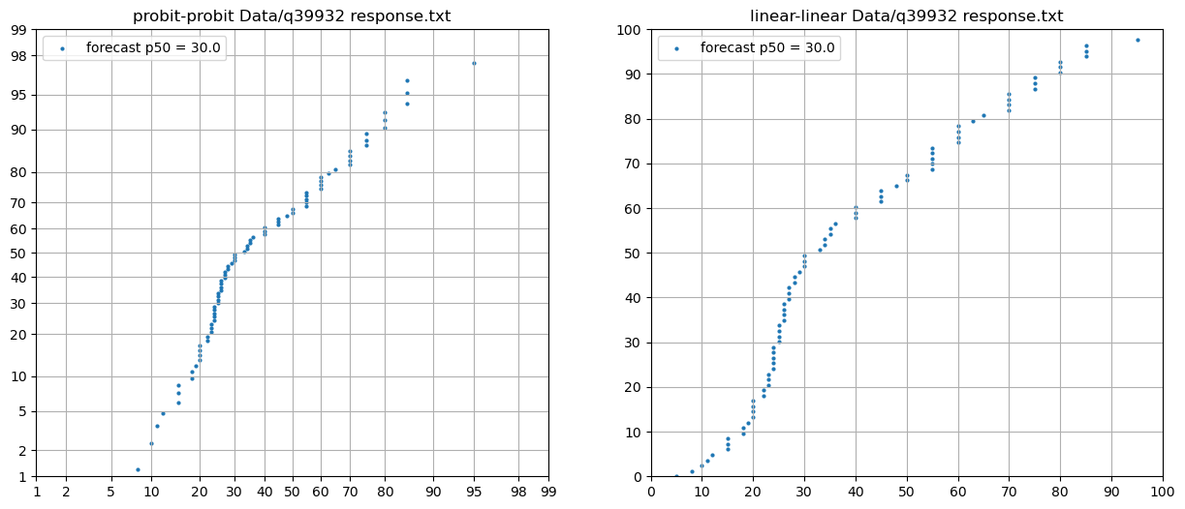
  - 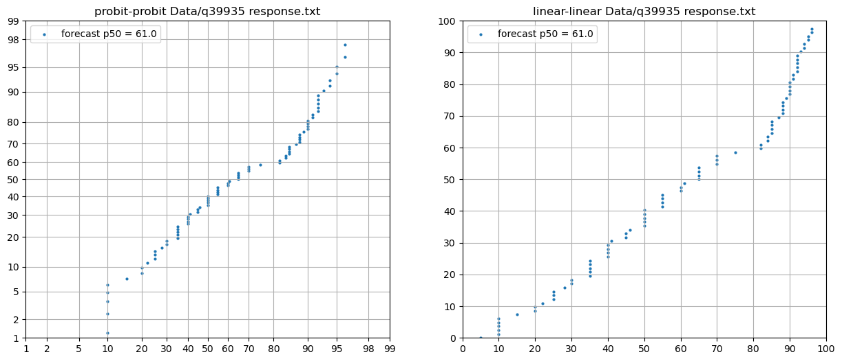

- Idea: Test impact of 36 instead of 72 scenarios by decimating 50%

- Change Numeric to Probit Aggregation from GPR. 01-21-2026
  - See jupyter test (in project folder)... good fit on test dat
  - Changed pctl increment to [1,5,10…90,95,99]
    - Better, but still blocky on edge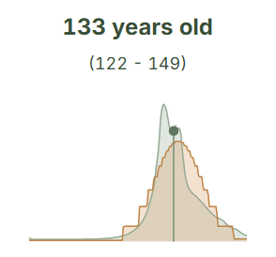
  - Try 1% percentile increment [1,2,3…97,98,99]
    - Definitely worked………………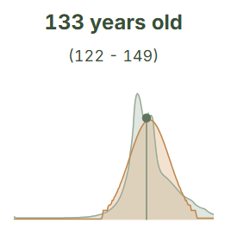
- Probit Aggregation for Numeric Questions running in production bot as of ~6pm January 21, 2026
  - See “C:\Users\Donni\projects\metac_bot_Spring_2026\conversation and context docs\Probit Aggregation Implementation Session 01-21-2026.md”
- Ideas for Binary
  - 1) Probit-Probit scale, use Probit aggregation with only 30 to 50
  - 2) Apply GSR in Probit-Probit space
  - 3) Find bend point closest to 50 percentile, use the half containing p50 to estimate p50 (probit-probit)
  - 4) Segment the curve to 2 or 3 pieces, use linear fit on piece containing p50. Revert to avg in case of bad r2.
  - 5) Just average all the values from p45 to p55…
    - doesn’t require any transforms.
    - Provides decimals
    - Doesn’t stick on an even number
    - …Just modify the current Jupyter notebook on Fall Data
  - Find away to reintroduce Bot judgement
    - Is it ok that it is after full aggregation? May let another bot review?
- Randomness Detector
  - See question 41576 in MiniBench: What will be the Mega Ball number in Mega Millions drawing on January 27 2026
  - 1) Check for bad fit… But my method will find a good fit to the noise (i.e. normal IS the expectation of noise)
  - 2) At the prompt level, make ask the model for expected type of fit
  - 3) Would have to dump out of the scenario methodology
  - 4) if it is random… just evenly divide among options
- Binary Questions biased towards NO, 01/23/2026
  - 9 Binary questions is Spring so far, only 1 has a significant over 50 consensus
    - But all 9 questions my bot forecasts are either in the 25-75 range
  - My Binary Test Questions:
    - 40 fall (probably) minibench questions in “002h Probit-Linear- Extract binary forecasts, test probit-linear, 01-10-2026”
      - 25 are strictly less than 50 (15 above)
      - 18 are less than 40, 1 is more than 60
      - Either my forecasts are biased towards no, the questions are (or both)
  - Jan 5, 2025 MiniBench
    - Almost exactly as many yes resolutions (14) as no resolutions (15)
    - Is it representative?
    - How did I do on the minibench binary questions?
- MiniBench Jan 5, 2026 (spring) (first with new bot)
  - Score breakdown
  - 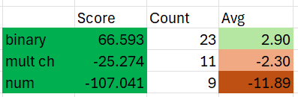
  - Looks like my binary prompt and multiple choice prompts were better last season
  - Keep the new numeric approach
- Ideas 01/23/2026
  - Return to LLM judgment for binary and multiple choice (let it play out for a week on the spring tournament?)
    - Remember, previously the multiple choice was a big point winner
    - Increase run count to… 8?
    - CHECK COST PER QUESTION
      - 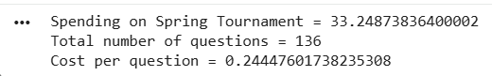
  - Use the new numeric for Spring
  - Consider updating numeric to allow LLM judgement
    - “...consider the scenarios and their objective likelihood, use your judgment to produce estimates of p1, p5, p10, p20…p90, p95, p99
    - Plot them up (recalculate the percentiles) make a new spline to fit them
- Consider language to identify true randomness (dice roll etc)

- Potential New Binary Prompt
  - Review you scenario forecasts
  - Consider the strength of evidence for the individual scenarios
  - Select a single best estimate of the probability of positive resolution
  - Part 2 Aggregation
    - Increase bot runs to…8, about $0.24 per question
    - Kick out extreme outliers
    - Bail out if more than one
    - Assign percentiles
    - Linear fit
    - Return regressed p50 value in probit space???
- Ideas 1/25/2025
  - Two sided normal distribution: Fit lower half of the distribution with one normal curve, and upper have with another. Allows asymmetrical distribution (test in jupyter with 6, 8, 54, 82 points).
- Ideas 1/27/2026
  - Extract forecast summaries, dates, from run logs
- Ideas 1/29/2026
  - Use inside average as best value estimate for binary
  - Use judgment rather than just fit to scenarios in binary
  - Add a judgement step to numeric questions prompt (probably have to output p10 to p90 by 10s followed by some sort of fit.
  - 2 sided normal for distribution
  - Elicit directly confidence weight for worlds (especially for numeric?)
    - For example, give the model $100 to distribute among the scenarios
  - An additional level of judgment for multiple choice (but does that push back to even numbers?)
  - Model diversification: not just OpenAI
  - News diversification… search?
- Ideas 1/30/2026
  - Write a substack on bot forecasting, forecasting
    - Use non-AI art… sketches
    - Our current context: AI explosion; End of post WW2 world order; Prediction markets; Population decline; Climate Change
    - Forecast methodology: pyramid (from base up): 1) background, baserates; 2) Logic; 3) details; 4 synthesized forecast.
  - Bail out of bad questions or questionable evalutations
- Minibench Results for Jan 5 tournament 01-31-2026
  - All categories of questions have more negative than positive responses
  - Conclusion: bring back judgment for binary and multiple choice
- Status and Change Plan 01-31-2026
  - Keep, latest numeric prompt and aggregation (already using probit numeric.
    - Watch results… potential to move to judgement for for numeric
  - Modify binary and multiple choice for judgement
    - Prompt and Aggregation (back to median)
    - Consider going to 8 LLM runs
    - Idea: Cut prompt bloat?... things the LLM probably will do better?
- Z-average aggregation testing 02/01/2026
  - See “06 Probit-Probit, Z-average, Inner Mean testing 02-01-2026.ipynb in C:\Users\Donni\jupyter notebooks\Competitions\Metaculus\Metaculus Bot\000 Tools
  - Results
    - Z-average works, gives a pretty good answer (maybe best)
    - Median gives most of the benefit
    - In this particular case, I drew 6 points from a normal distribution
      - normal_data_sim = 100 * rng.normal(0.06, 0.03, n_points) # individual forecasts range from 1 to 100
      - Simulation on with median=mean= 6%
    - Inner mean doesn’t make sense with so few points
    - 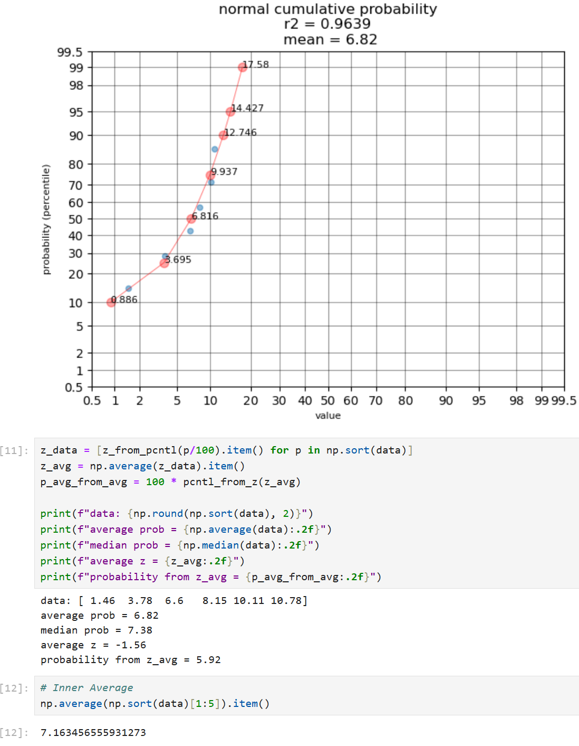

- Plan after testing z-average aggregation
  - Retain z-average as for future implementation (it seems to be best method for binary, but complicated)
  - Use simple median with 6 bot runs at this time
  - Change prompt final forecast to reasoning instead of scenarios
    - Still do scenarios, but add reasoning step at the end
- Notes 02/01/2026
  - Binary prompt working at 1:08 pm
  - Multiple choice prompt working at 3 pm
- Bot versions history 02/02/2026
  - Binary
    - BV01: 01/05/2026 to 02/01/2026
      - Changes (from Fall2025 bot)
        - LLM = OpenAI: GPT 5.2
        - The entire range scenarios
        - Aggregation by Gaussian Process Regression (GPR)
        - 4 bot runs
      - First Spring2021 Question: 41518
      - First Minibench Question: 41391
    - BV02: 02/01/2026 to
      - Changes (from Fall2025 bot)
        - New judgement based final forecast after world scenarios
        - Aggregation: Median
        - 6 bot runs
      - First Spring2021 Question: 41906
      - First Minibench Question:
  - Multiple Choice
    - MV01: 01/05/2026 to 02/01/2026
      - Changes (from Fall2025 bot)
        - LLM = OpenAI: GPT 5.2
        - Aggregation by repeated GPR on each option
        - 4 bot runs
      - First Spring2021 Question: 41451
      - First Minibench Question: 41379
    - MV02: 02/01/2026 to
      - Changes
        - Logic of scenario generation… more clear that scenarios are lo-mid-hi for each option (replacing trend and chaos scenarios)
        - Median aggregation
        - 6 bot runs
      - First Spring2021 Question: _________
      - First Minibench Question: _________
  - Numeric
    - NV01: 01/05/2026 to 01-21-2025
      - Changes (from Fall2025 bot)
        - LLM = OpenAI: GPT 5.2
        - by Gaussian Process Regression (GPR)
        - 4 runs per model
      - First Spring2021 Question: 41468
      - First Minibench Question: 41383
    - NV02: 01-21-2025 to
      - Changes
        - Probit aggregation in place of GPR
        - Distribution defined on 1 percent increment
        - 4 bot runs increased to 6 bot runs on 02-01-2026
      - First Spring2021 Question: 41836
      - First Minibench Question: 41576 (2026-01-19 mini)
- Actions 02/02/2026
  - Check why summary for 41906 includes :Methodology: Multi-world scenario analysis with GPR aggregation”, a binary question (Numeric
  - Why 41569 doesn’t a short summary instead of long (numeric)
  - 41894 numeric with discrete values is ok
  - Check the multiple choice
  - Let things run for a day to gather logs?
- Ideas 02/03/2026
  - BASE RATES for NUMERIC PROMPT
- Ideas 02/04/2026
  - Jeff Mohl, Emdash (Predictably) for ideas from his substack
    - Means instead of Medians for aggregation
    - GPT 5 instead of GPT 4o for search
    - Web search with prompt for anomalous values check
  - Jordan Berman idea
    - Use claude with prompt to grade quality of individual LLM forecasts
    - My extensions
      - Generate numeric scores of forecast quality
      - Correlate the quality scores against forecast outcomes
      - Integrate quality scoring in the aggregation to weight the individual run forecasts
- Ideas 02/05/2026
  - Upgrade my cost tracking tool to save each run in a spreadsheet (sheets or excel)
- Ideas 02/06/2026
  - Substack next steps list
  - Substack write a draft first post
- Ideas 02/07/2026
  - Test alternatives to normal distribution on numerica questions (community seems to be pointier, but longer tails)
    - Almost like back to back exponentials
  - Look at TWSummers forecast summaries
  - Force my bot to make notes about base rates (note that base rates are only specified for binary and multiple choice questions. At least some binary, full summaries include base rate discussion) so the need is for the condensed summary.
  - Revisit scoring calculations - is maximum and minimum possible Binary score the same (around +/- 998)
  - Calculate numeric scores with a jupyter notebook to understand numeric scoring
  - Calculate multiple choice scoring.
  - Monte Carlo scores on a binary question. Start with completely random
  - Brainstorm, and understand next steps for a distribution type recognizer.
  - Brainstorm and understand next steps for convert-multiple-choice-to-numeric option
- More ideas 02/07/2026
  - Distribution Decider
    - Ask AI to make a list of questions to ask that will help decide what type of distribution to use for numeric questions
      - EG:
        - Is the value always more than zero?
        - Is the value always less than zero?
        - Can the value be zero
        - Is the distribution expected to be symmetric
        - Is log of value expected to be symmetric
      - Available Distributions for assignment
    - Randomness detection and assignment
      - Cases
        - Single dice
        - Nothing but noise
        - Multiple deterministic probabilities (2 dice, combine draws)
  - Optimize pointy + tails distribution type.
    - Eyeball fits of prior numeric questions
    - Use those values to quantify a number of questions
    - Find best fit to maximize score
  - Check if value range for forecast is available in the forecast question

